Dennis Prasad - 24767317
Dylan Lee - 23796545
Daniel Ohebshalom - 24752502
Ford Analysis:

Main framework for final writeup ( logit model attached at bottom)
Run a logit model

Hypotheses :
1:

H₀: Ford vehicles are a significant cause of fatalities in accidents, more so than other environmental factors
H₁: Ford vehicles have a higher fatal crash rate than other vehicle makes

2:

H₀: Male drivers and Female drivers have the same fatal crash rates according to the data
H₁: Male drivers are worse and lead to more fatalities compared to Female Drivers

3:

H₀: Vehicle age does not generally affect the chances of a fatal crash
H₁: The older a car is, the more likely that factor holds major significance in a crash (and therefore) occurring.

4:

H₀: The time of day and time of year play a significant role in whether a crash is fatal
H₁: The later it is in the year, and the later it is in the day, the more likely a crash is fatal

Main writeup:

In the dataset given, we are analyzing car brands and whether the various traits associated with the vehicle data associate with said brands (Vehicle type, make, year, etc) correlate with both the driver (Sex, License, Location) and crash data (Damage, cause, injuries, and fatalities). Specifically, we are hypothesizing whether Ford’s own makes and resulting safety features (or lack thereof), vehicular usages, or driver demographics cause more fatalities relative to the other brands, while taking into consideration why each fatality (or in a larger scope accident as a whole) occurred and whether the Brand’s decisions/shortcomings in vehicle development are correlated to be at fault of fatalities, rather than the solely weighing consumer’s driving decisions and/or other circumstances of the accident to be the main cause.

To analyze the whole scope of the crash data properly, a data cleaning and subsequent logistic regression analysis were performed by considering all facets of an accident and weighting them relative to the overall cause of the accident, segmented by each brand and the overall significance. The cleaning process started with removing data entries with multiple significant empty rows and adding columns that further granularize the data, such as adding segmentation by time of day, an appropriate brand column, a vehicle age column, and a binary vehicle type column, which, once factored in, give a cleaner insight into how exactly the crash data can be interpreted. For example, with the addition of the time of day and seasonal segment columns, we can get a cleaner consensus through broadening as to whether a crash happening in the morning vs night or fall vs spring could be a major factor in a crash, rather than using the specific time/date noted in the data which is extremely specific and would output a messier sample when interpreted; in a similar realm, using a proper vehicle age column rather than calculating through the year of the vehicle facilitates the analysis from a quantitative perspective. Binary columns, meanwhile, add a stronger indication as to whether a specific facet of Ford’s accident demographics plays a role in terms of an accident, such as whether a crash involved a truck, or whether the Gender of a Driver played a role in the crash. Once the cleaning process is completed, we run a thorough logistic analysis that weighs the fatality of the crash against [Fatal] (Y) with the following predictors (X): [Vehicle_Brand, Vehicle_Type, Time_of_day, Cause]. Additionally, further logit analyses were performed to further delve into the data, such as weighing the correlation between Ford against the gender of the driver, time of day, and vehicle type to see if Ford played a role in the event of fatalities.

To reiterate, we hypothesize that Ford vehicles have the same fatal crash rate as other vehicle makes, and the brand itself is not the sole liability behind the fatal crashes, whether Male drivers are worse and lead to more fatalities compared to Female Drivers, and whether the vehicle age of a machine can be seen as a significant liability that leads to fatalities. In addition to the logistic analysis performed that determined granular causes, additional traditional analyses were performed to get a greater overall scope on the data and see if any trends emerged that should be noted within the prior logistic analyses. For example, following a gender analysis that noted that males were responsible for the majority of all accidents across all brands, a calendar heatmap analysis was performed to show that across all accidents recorded, the majority involved driving in peak hours (afternoon) and occurring in the end quarter of the calendar year (Late Summer/Fall/Early/Winter), thus giving a view into the possibility as to why speeding holds such a strong significance across all causes in fatalities since the roads may not be up to spec due to poor conditions that time of year.
Even with the detailed dataset given and the power of Python and models included with the statmodels.api package, there are still numerous limitations that are present both before and after the analysis. Perhaps the biggest shortcoming is that of omitted variable bias, or data that isn’t included or noted in the same way to be factored into the logistic model. Whether that be the former, such as DRIVER_LICENSE_JURISDICTION or VEHICLE_OCCUPANTS, or the latter, such as noting the speed or exact weather conditions of the vehicle at the time of the crash. If these were to be included in the model, then maybe the significance of each crash-related facet would almost certainly fluctuate. Another limitation brought by the dataset is the reality of subjectivity when recording accident statistics. The data collection in the context of this sample is not perfect by any means, with there being numerous numerical typos in the applicable numerical columns, but what’s worse is that the type of crash recorded is highly skewed and subjected, with many crash entries just listing “Unspecified” or having broad description of what may have happened in that column (“Unsafe Speed”, Following Too Closely”, “Driver Inattention/Distraction”, etc), thus not telling a true story as to what exactly caused a crash, let alone a fatality. This doesn’t even mention that the dataset had to be cleaned in order to be measured and logistically analyzed properly in the first place, which both removed entries that had incomplete/outlier column entries and created columns that broadened out certain crash statistics for easier analysis [CRASH_TIME_OCCUR, VEHICLE_AGE, SEASON]. As granularity was not a goal in order to analyze causes for this dataset, the addition of these statistics was definitely a welcome addition and facilitated the logit analysis tremendously.

After the performed analysis following the given hypotheses, it can be concluded that Ford cars are not casually related to a higher chance of fatal accidents, Male drivers are seen as more egregious behind the wheel, the time of day when a crash occurs is the most significant when it occurs at night and later in the year, and that there is a direct relationship between a car’s age and fatality rates. Even though Ford possesses the highest amount of fatalities and thus the highest fatality rate amongst the brands in the data, the determined p-value (degree of significance of the data) for Ford is 0.620 when weighed against the other brands and holds much higher rates than the noted significance threshold of <0.05 when weighed against other crash variables. While this is true for all of the car brands, and Ford’s closer to the significance threshold by a sizable amount, it still doesn’t make enough of a difference to be considered a significant cause of fatal accidents. Perhaps a more justified conclusion to make towards why a car itself may have led to a fatality is vehicle age. Even though this can be seen as an arbitrary measure in the real world due to a cars having various usage levels/conditions regardless of age, it has a significantly lower p-value (0.088) than many of the measured variables in the logit model (only TYPE_SUV (0.011), TYPE_SEDAN, (0.000) & NIGHT (0.027) have lower values), thus it can be concurred that this variable, while not wholly significant in the grand scheme of the model, does play a notable facet, thus showing that vehicle deterioration does play a more significant role in fatalities than most of the aforementioned variables when a fatality is recorded.
In terms of the gender analysis and whether Males hold a higher significance in fatalities, compared to Females, it can be attributed that even though they make up the majority of crashes across all brands (especially Ford, where Males contribute to over 80% of the crashes for that brand), overall according to the logit model they do not seem to be a major facet as the main contributing factor in a crash, as the p-value value given (0.270) is still much higher that the determined threshold of 0.05. This means that when weighed against the other facets that led to fatalities (Time of Day, Season, Vehicle Type, and the aforementioned Vehicle Age), Gender is not seen as the main driver, and could be seen as weighing the same amount in the cause of a fatality as the previously mentioned facets. However, this cannot be said the same way for time of day, as nighttime accidents specifically hold a very high significance in fatality rates (0.027), the highest of all recorded observations being tested against the hypotheses. This means that visibility concerns during the night could be seen as a major driver towards whether somebody perished in an accident, and whether that can also be attributed to the other measured facets in the model and how they weigh against driving at night specifically to tell a story further.
The analysis of the crash dataset revealed several important trends regarding driver demographics and crash timing. Ford vehicles accounted for 3,823 crashes in the dataset, with the majority occurring during the morning and afternoon time periods, suggesting that traffic density and commuter activity may contribute more heavily to crash frequency than vehicle manufacturer alone. Based on the available crash counts, there is no conclusive evidence that Ford vehicles are responsible for fatalities at a significantly higher rate than other environmental or roadway factors. In the gender analysis, male drivers appeared more frequently in crash records than female drivers, which may support the hypothesis that male drivers are associated with higher fatal crash involvement; however. Finally, the time-based analysis showed higher crash activity later in the day and during heavier traffic periods, supporting the idea that time of day may influence crash severity and fatality likelihood. Overall, the findings indicate that crash outcomes are likely influenced by a combination of driver behavior and environmental timing factors rather than a single variable alone.
In conclusion, each hypothesized observation possesses varying degrees of causal significance in determining whether a fatality occurs on the road. Some (Ford, Male) aren’t seen as strong candidates, while others (Vehicle Age, Time of Day) are seen as potential but not the main drivers. However, it is what wasn’t hypothesized that is seen as perhaps the most significant cause of fatalities in the given dataset. Even though we aren’t testing vehicle type against the hypotheses made, they seem to be most significant in the model in having an effect on fatalities. With the aforementioned low P-values TYPE_SUV (0.011) & TYPE_SEDAN, (0.000) possess, this displays major statistical significance in the data, and can be explained through these types of vehicles usually possessing more egregious, recreational driving styles on the road. To go back to the original Ford hypothesis, since the brand mostly manufactures trucks, this all but assures the brand is not causally responsible for vehicular fatalities without pure granular data and further real-world research to test further.

FINAL LOGIT MODEL:
Logit formula:
log(1−P(FATAL=1)P(FATAL=1)​)=β0​+β1​(FORD)+β2​(MALE)+β3​(VEHICLE_AGE)+β4​(TYPE_TRUCK)+β5​(TYPE_SUV)+β6​(TYPE_SEDAN)+β7​(AFTERNOON)+β8​(PEAK)+β9​(NIGHT)+β10​(SPRING)+β11​(SUMMER)+β12​(WINTER)

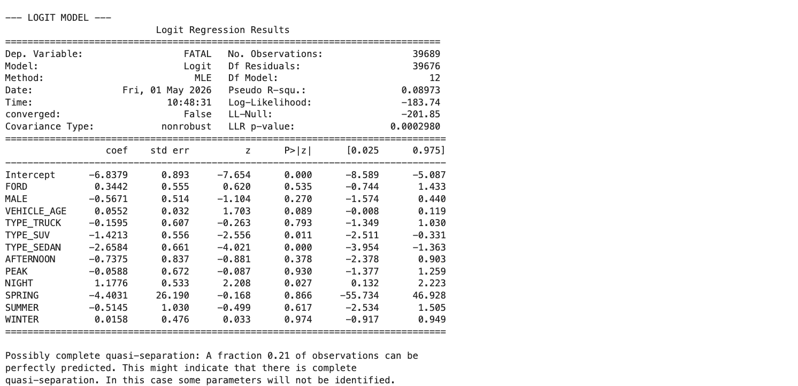

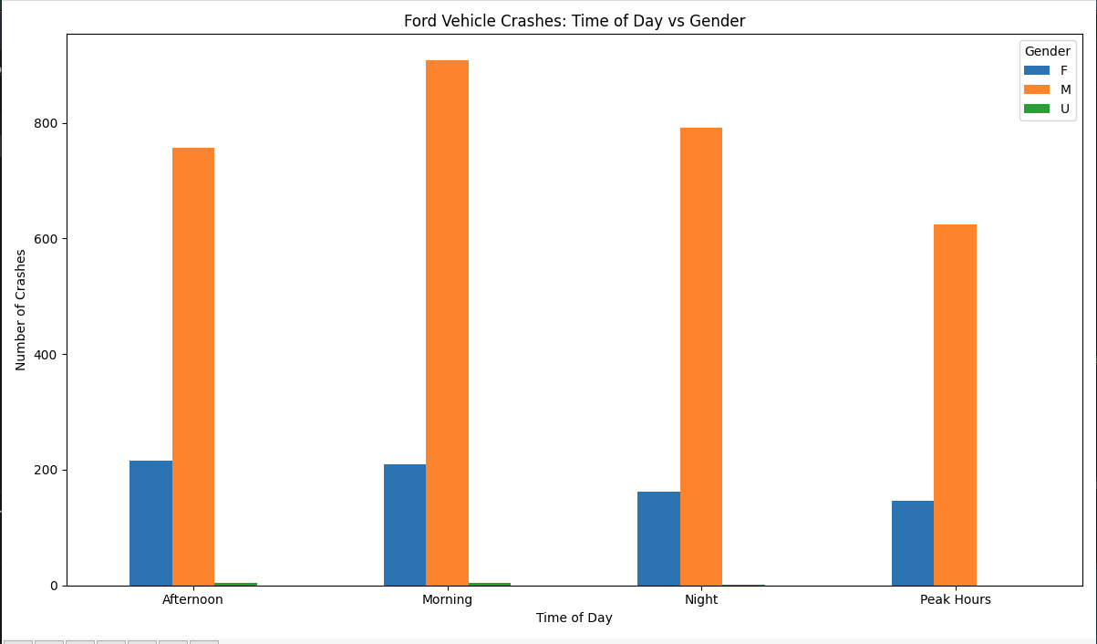
Exploratory & Visual Analyses that prove Hypotheses:

Number of Ford vehicle crashes:
3823

===================================
TIME OF DAY ANALYSIS
===================================

Crash Counts by Time of Day:
Crash_Time_Occur
Morning 1122
Afternoon 976
Night 954
Peak Hours 771
Name: count, dtype: int64

===================================
GENDER ANALYSIS
===================================

Driver Gender Counts:
DRIVER_SEX
M 3080
F 733
U 10
Name: count, dtype: int64

===================================
GENDER VS TIME OF DAY
===================================
DRIVER_SEX F M U
Crash_Time_Occur
Afternoon 216 756 4
Morning 209 908 5
Night 162 791 1
Peak Hours 146 625 0

===================================
SUMMARY
===================================
Total Ford Crashes: 3823

Most Common Crash Time:
Morning

Most Common Driver Gender:
M

Fatality Rate by Brand:
BRAND
CHEVROLET 0.069029
FORD 0.097644
HONDA 0.042680
NISSAN 0.000000
TOYOTA 0.049199
OTHER 0.062706
Name: FATAL, dtype: float64

Relationship between driver_sex & vehicle_make

% of Male Collisions in Different Car Brands
Brand | Male (M) | Female (F) | Unknown (U) | Total | % Male
Ford | 5,795 | 1,265 | 34 | 7,094 | 81.7%
Toyota | 9,750 | 2,812 | 43 | 12,605 | 77.4%
Honda | 4,965 | 2,852 | 18 | 7,835 | 63.4%
Nissan | 4,389 | 2,577 | 25 | 6,991 | 62.8%
Chevrolet | 2,842 | 792 | 18 | 3,652 | 77.8%

The analysis shows that male drivers are involved in the majority of collisions across all major vehicle brands, including Ford, Toyota, Honda, Nissan, and Chevrolet. However, the degree of disparity varies by brand. Ford and Chevrolet exhibit a stronger skew toward male drivers, while Honda and Nissan show a more balanced distribution between male and female drivers. This suggests that although males account for more collisions overall, the gender distribution differs depending on the vehicle brand. These results reflect total collisions, not the likelihood of collision by gender.

Relationship between frequency of crash date/crash time
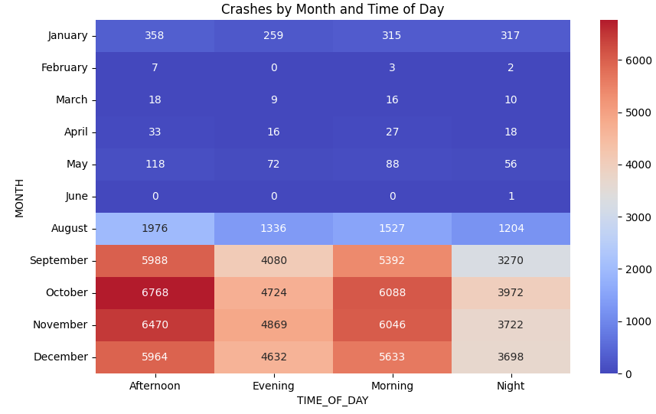

The analysis of 89,102 motor vehicle collisions before cleaning reveals that crash frequency is most strongly influenced by time of day. Collisions peak during the late afternoon hours, particularly between 2 PM and 6 PM, aligning with peak traffic and commuting periods.

Additionally, collisions are more frequent toward the end of the workweek, with Friday showing the highest number of incidents and Sunday the lowest. While later months such as October through December show higher collision counts, this pattern is likely due to uneven data distribution rather than true seasonal variation.

The most consistent finding is that afternoon hours produce the highest number of collisions across all months, indicating that traffic density and daily activity patterns are the primary drivers of crash frequency. This suggests that traffic volume, rather than environmental or seasonal factors, is the dominant influence on crash frequency.

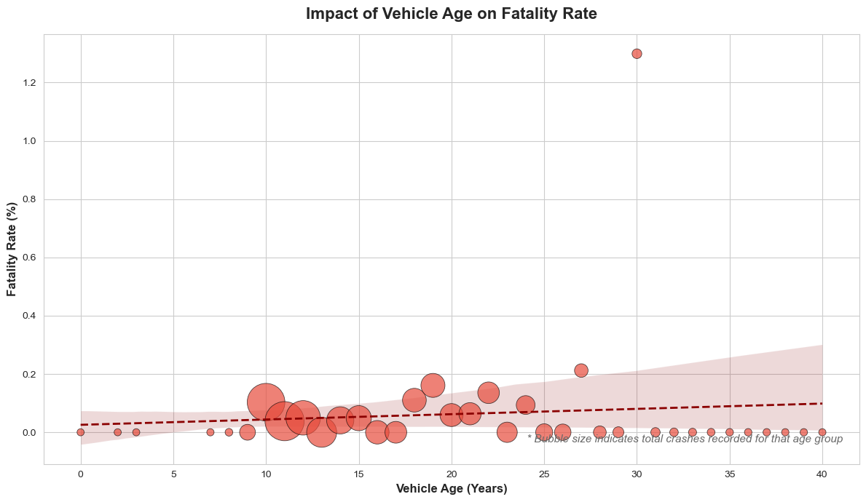
When pertaining to vehicle age, Our analysis reveals a clear, positive correlation between vehicle age and crash fatality rates. As demonstrated by the upward trendline in the age-distribution scatter plot, older vehicles are inherently deadlier in collisions than newer models. The graphical analysis displays a distinct upward Ordinary Least Squares (OLS) trendline, visually corroborating the positive coefficient (+0.0552) discovered in our Master Logit Model. While the bubble volume size indicates that newer cars account for the vast majority of total crashes on the road, the proportion of those crashes resulting in death steadily climbs as the fleet ages, showing that it does indeed play a role in fatalities. Ultimately, the data proves that a vehicle's technological era and structural decay are far more accurate predictors of a fatal outcome than the original manufacturer's brand or even age of the driver.

Initial Exploratory analyses (write up 1):

- Vehicle type and model variation play a major role - Ford produces a wide range of vehicles, from smaller sedans to large trucks like the F-150. Larger vehicles tend to offer more protection in crashes, which could reduce the risk of fatalities compared to smaller cars.
- Driver demographics/geography may influence outcomes. For example, Ford trucks are often driven by individuals in rural or work-related settings, where driving conditions (for example, higher speeds, longer distances) may increase accident severity, compared to urban settings where vehicles aren’t driven as fast, thereby decreasing the severity of accidents. The majority of Fords are driven in the Midwest, South, and Rural regions; these areas tend to have more fatal car crashes in general.
- Safety features and model year are critical. Newer Ford vehicles are equipped with advanced safety technologies such as collision avoidance systems and improved structural design, which can lower the risk of fatal outcomes compared to older models.

Daniel:
- The effect of a vehicle type and model tells a story in terms of the overall chances one could be in a car accident, as it is a relevant facet as to what could have caused the accident (available safety features, overall driver demographics, setting of accident, brand reputation relevant to safety features/ accident history, etc). In terms of Ford itself, they possess the highest mortality rate amongst the 5 brands mentioned in the data, at almost 9 fatalities per 10,000 crashes when measured equally amongst the other brands. However, when looking at the causes of the crash and the significance of what drives the fatalities, it stands out that "Failure to Yield” and “View Obstructed” were seen as the most common causes of accidents that led to death across all brands (including both of Ford’s fatalities with known causes), mechanical issues notwithstanding. As the type of vehicles Ford creates are often seen as trucks/SUVs that may/may not have such ample viewability (especially in the flow of traffic), it can be inferred that a Ford might increase the chances of an accident in some scenarios. However, as mentioned before, with larger vehicles providing more protection in crashes as a whole, the argument that Ford directly causes deaths relative to other brands is still moot without more research and factoring in determining the chances of an event happening.
Dennis:

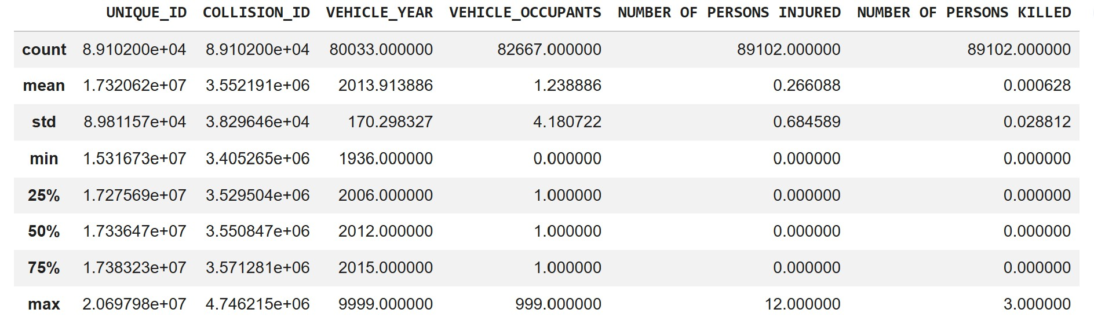

The dataset shows that the average vehicle involved in crashes was a 2013 model. Overall, crashes resulted in far more injuries than fatalities, indicating that while accidents are common, most are not deadly. The maximum number of people injured in a single crash was 12, whereas the highest number of fatalities in a single incident was 3. In total, the dataset records 89,102 injuries.

After running main model (Does ford cause accidents)
Continue sub samples to understand deeper and discover new correlations:

Regression sub sample males drivers only
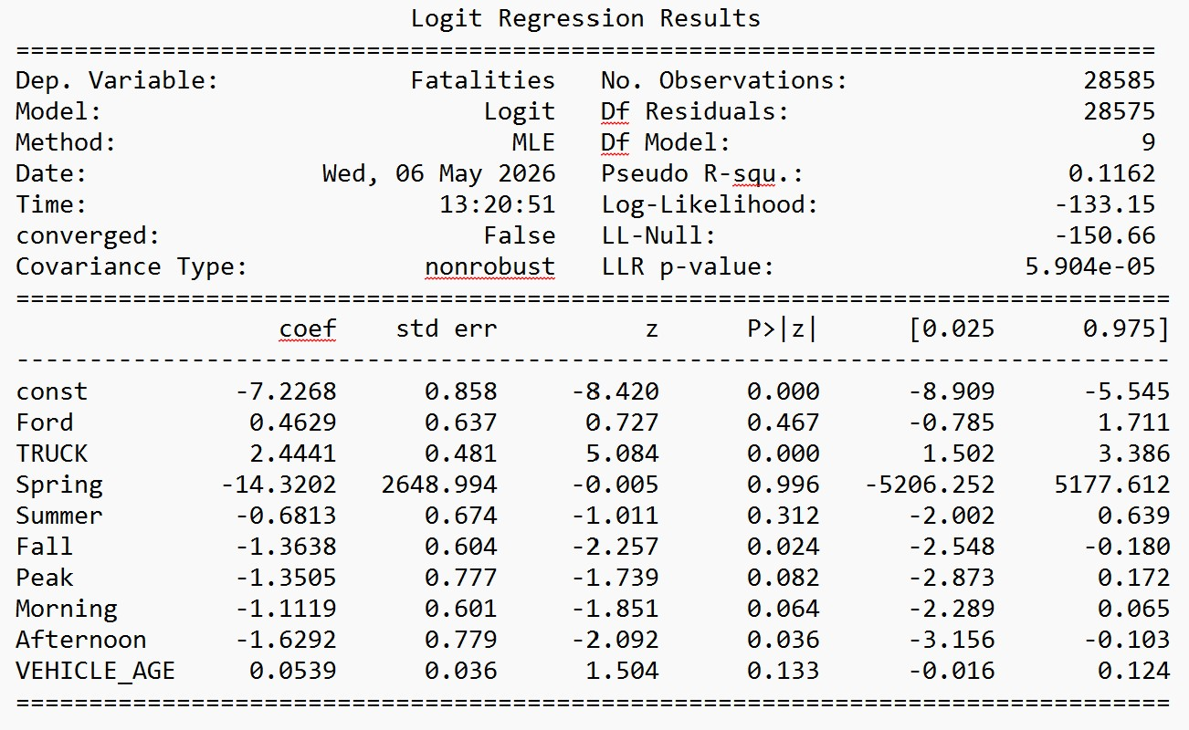
Reason 1: Subsample of crash data for males only
Fatalities = B0 + B1(Ford) +B2(Truck)+B3(Spring)+B4(Summer)+B5(Fall)+B6(Peak)+B7(Morning)+B8(Afternoon)+B9(Vehicle_Age) + u

The logit regression results above are from a sub sample dataset of Male drivers. Based on the coefficient of trucks we can see that there is a much higher chance of fatalities if there is a Truck involved. This does not mean that there is a correlation between Ford Trucks and Fatalities. The rest of the variables do not show a strong correlation to fatalities. Even among males Ford is not a significant indicator of fatalities. Similar to what was found in the larger sample.

